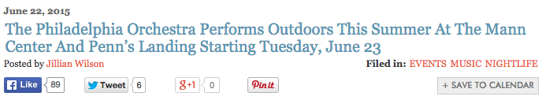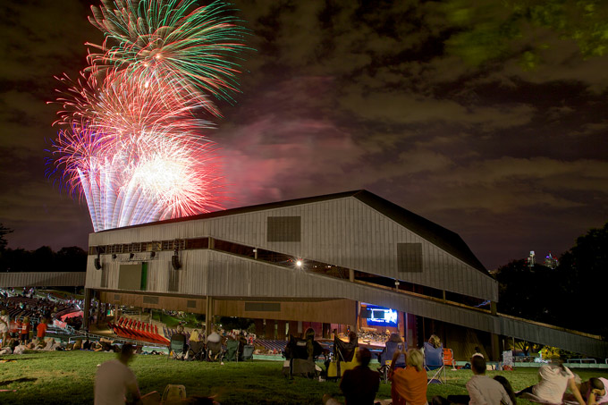This summer, The Philadelphia Orchestra returns to its summer home — The Mann Center — with six concerts in June and July.
(Photo courtesy The Mann Center for the Performing Arts)

The Mann Center for the Performing Arts, one of the city’s favorite outdoor music venues hosts a glorious summer season complete with musical acts by some of the biggest names in the biz and the city, too.
The Philadelphia Orchestra will return to its summer home — The Mann Center — to play six concerts throughout June and July.

The Orchestra will start its Mann Center residency tomorrow, June 23 with Tchaikovsky with Fireworks, a concert featuring some of Tchaikovsky’s most-known works — Swan Lake, 1812 Overture and more. The show concludes with a fireworks show high above the Fairmount Park concert venue.

The series continues this week with a screening of The Godfather on Thursday, June 25. The Philadelphia Orchestra will perform the score as the classic film plays.

On Friday, June 26, the concerts wrap up for June (but take note, the shows continue in July!) with A Night of Gershwin with The Philadelphia Orchestra. Listen to the talented musicians perform celebrated songs by the Gershwins, including excerpts from Porgy and Bess and An American in Paris.

Tickets prices vary depending on the show, but all tickets start at just $20 or $25. Tickets are availableonline.
Bonus: Did we mention that guests of The Mann Center can pack a picnic (even beer and wine!) for the shows, t
too? Deal!

See below for the full schedule of The Philadelphia Orchestra shows at The Mann.
Beyond The Philadelphia Orchestra’s alfresco concerts at The Mann, folks can also catch the group outdoors at Great Plaza at Penn’s Landing for a free neighborhood concert on Thursday, July 2 in celebration of the July 4th festivities in Philadelphia.
Don’t miss the chance to take in our city’s Orchestra in the great outdoors.

The Philadelphia Orchestra at The Mann
When: June 23, 25, 26, July 23, 24, 25
Where: The Mann Center for the Performing Arts, 52nd Street and Parkside Avenue
Cost: Varies
More info: www.manncenter.org

The Philadelphia Orchestra Free Neighborhood Concert
When: Thursday, July 2, 8 p.m.
Where: Great Plaza at Penn’s Landing, 101 S. Columbus Boulevard
Cost: Free
More info: www.philorch.org
See below for the full performance schedule.
• June 23: Tchaikovsky with Fireworks
• June 25: The Godfather Live with The Philadelphia Orchestra
• June 26: A Night of Gershwin with The Philadelphia Orchestra
• July 23: The Fellowship of the Ring with The Philadelphia Orchestra
• July 24: Diana Krall with The Philadelphia Orchestra
• July 25: All-Beethoven with The Philadelphia Orchestra

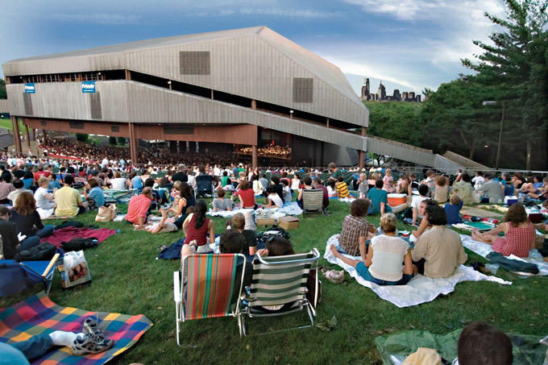Grab your friends, pack a picnic and listen to the city’s premier orchestra perform in the Fairmount Park music venue.
(Photo courtesy The Mann Center for the Performing Arts)

